Project Name |  | Confidentiality Level
DBMS Project |  | For Recipients’ Reference Only
Project ID | Version | Document Code
58888 | 1.0

DBMS Project Start Report
Revision Record
Date | Revision Version | CR ID /Defect ID | Sec No. | Change Description | Author
2017-4-26 | 1.0 |  |  | Begin

Content
1. Project Proposal 5
2. Team building and Schedule 5
3. Risks Evaluating and Mitigating 5

Keywords: DBMS、RDBMS、MFC、SDI Dialog、C/S 、MVC
Abstract :This system is the version of the database management system, including database creation, database table management, record addition and query, index creation and implements, multi-user, concurrency processing, transaction procession, database backup and recovery, etc. This document describes the design of each functional module to help the software developers analyze and design the software better. At the same time, it helps the clients to give better suggestions.
List of abbreviations :
Abbreviations | Full spelling | Chinese explanation
SDI | Single Document Interface | 单文档界面
MFMFC | Microsoft Foundation Classes | 微软基础类库
DBMS | Relational Database Management System | 关系型数据库管理系统
C/S | Client/Server | 客户/服务器模式
MVC | Model View Controller | 模型（model）—视图（view）—控制器（controller）

Project Proposal
- Project ID:
58888

2. Project Introduction:
Database Management System is large-scale software which can manipulate and manage the database. It is used to establish, use and maintain the database, and called DBMS for short. It manages and controls the database in a unified manner to ensure the security and integrity of the database. The user accesses the data in the database through DBMS. The database administrator also maintains the database through DBMS. It can make many applications and users establish, modify and query the database through different methods at the same time or different moments. Most DBMS provide DDL and DML for users to define the schema and permission constraint of the database, and implement the data operation:add,delete,etc.
3. Project objective:
（1）Implement the project with DDL, DML and DCL functions.
（2）The project mainly implements functions like: Database Management, Table Management, Field Management and Data management, etc
（3）The interface of the project requirements beautiful, generous, clearness and better user experience.
4. System boundary:
Gaming peripherals are user’s inputting data. The data source is database file, database description file, table description file, table definition file, integrity file and index description file.
The basic functions of DBMS are:Create database, Create table, description file and define table structure, show table structure, insert record and select records.
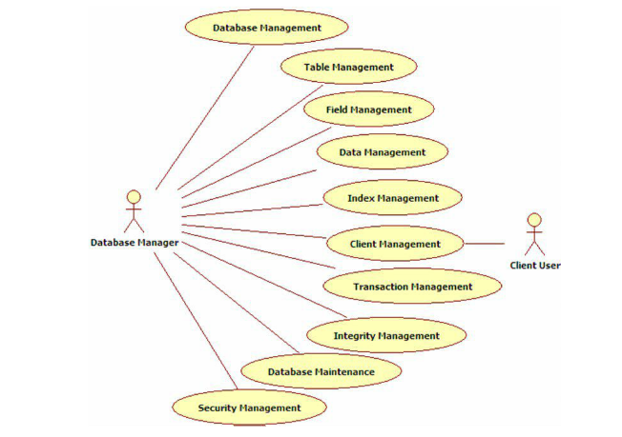

5. Workload assessment:
Module | Sub-module | Workload（person/day） | Description
Create Project |  | 1 | Create a MFC SDI application
Interface Design |  | 1 | Design main interface of database management systems
Data structure |  | 1 | Design data structure to implement core functions of DBMS
Exception Handling |  | 1 | Design the exception handling method in the program
Create Database |  | 3 | Create a default database, named “Ruanko”
Create Table Description file |  | 3 | Generate table description information
Define Table Structure |  | 3 | Input the field information of the table, save into the table definition file(.tdf), and display in the tree view and the list view.
Show Table Structure |  | 3 | This function includes read *.tdf file and display table structure
Insert record |  | 3 | Insert a row of record in a specified table, and save to the record file(*trd)
Select records |  | 1 | Read the *.trd file of the specified table, and select all record, then display in the list view.
Workload in total | 2 persons/day
Remarks: Person/day means workload of the number of person & day

Team building and Schedule
1. Project Plan： Implement the basic technical of DBMS.

2. Chief Project Manager： Number：15301039 Name：何方溥

3. Project Manager： Number：15301036 Name：关宸

4. Source of Staff：Student

Risks Evaluating and Mitigating
1. Technical Risks：
(1)Unfamiliar for VS2012, use less of MFC Dialog, MFC SDL.
(2)Not familiar with DDL function, DML function and DCL function of the DBMS.
Resolution:
For self-learning and timely communication, mainly learn about the database knowledge.
2. Management Risks：
(1)Plan is not fully, so it is different to keep with the project schedule.
(2)The concept of the project is too much
Resolution：
- For project development, we should fully prepared and effective for time management.
- Seize the time to prepare the individual software quality.
3. Other Risks：
(1)Because of power outages and other reasons, resulting in the loss of project data.
(2)Network status is poor, resulting in broken network.
Resolution：
- Back up the data frequently.
- Reasonable to arrange time to set aside space to solve risk.

